Section 1: Case Summary

Scenario Title: | Nightmares Course: Hyperkalemia
Keywords: | Medicine, Cardiology, ACLS
Brief Description of Case: | This case involves the diagnosis and management of hyperkalemia. If not treated appropriately the patient will progress to ventricular fibrillation arrest.

Goals and Objectives
Educational Goal: | Recognition of hyperkalemic emergency and treatment of hemodynamically unstable bradycardia
Objectives:  (Medical and CRM) | - Review an approach to and differential for bradycardia  - Provide specific treatment for severe hyperkalemia  - Prioritize initial investigations and therapies  - Maintain situation awareness of an unstable patient  - Communicate the clinical situation clearly to consultants
EPAs Assessed: | TD 1: Recognizing the unstable/critically ill patient, mobilizing the health care team and supervisor, and initiating basic life support.

Learners, Setting and Personnel
Target Learners: | ☒ Medical Students | ☒ Junior Residents | ☐ Senior Residents
 | ☐ Staff Physicians | ☐ Inter-professional | ☐ Other
Location: | ☒ Sim Lab | ☐ In Situ | ☐ Other
Recommended Number of Facilitators: | Instructors: 1
 | Confederates: 1
 | Sim Techs: 1

Scenario Development
Date of Development: | 2015
Scenario Developer(s): | Dr. Tim Chaplin
Affiliations/Institutions(s): | Queen’s University
Contact E-mail:
Last Revision Date: | Jan 10/2020
Revised By: | Dr. Chris Heyd
Version Number: | 1.1

Section 2A: Initial Patient Information

- Patient Chart
Patient Name: Doug Smith |  |  | Age: 67 |  |  | Gender: Male |  | Weight: 80kg
Presenting complaint: Generally unwell / Medication error
Temp: 36.5 | HR: 40 | BP: 90/50 |  |  | RR: 18 |  | O₂Sat: 99% |  | FiO₂: room air
Triage note:
You’ve been called to assess a 67M on the general medical floor. He was admitted 3 days ago for a community acquired pneumonia and is now awaiting discharge home once out-patient services can be put in place. He was noted to be hypokalemic on labs this morning (3.2 mEq/L) and the daytime resident ordered KCl 10mEq in 100cc NS bolus, to be given once. On her initial assessment, the overnight nurse found that he was actually placed on an infusion over the last 10 hours and the patient is now confused and bradycardic.

Allergies: NKDA
Past Medical History:  HTN  COPD  Smoker |  |  |  | Current Medications:  IV KCl replacement  Ceftriaxone  Azithromycin  Ramipril  HCTZ

Section 2B: Extra Patient Information

A. Further History
Patient vague and repetitive, unable to provide any useful history.

B. Physical Exam
Mental status: mild confusion, repetitiveness
Otherwise unremarkable exam

Section 3: Technical Requirements/Room Vision

A. Patient
☒ Mannequin (Adult)
☐ Standardized Patient
☐ Task Trainer
☐ Hybrid
B. Special Equipment Required
Standard airway equipment
Defibrillator

C. Required Medications
ACLS meds
Salbutamol nebulizer
Insulin/glucose

D. Moulage
IV line in place

E. Monitors at Case Onset
☐ Patient on monitor with vitals displayed
☒ Patient not yet on monitor
F. Patient Reactions and Exam
Confusion

Section 4: Confederates and Standardized Patients

Confederate and Standardized Patient Roles and Scripts
Role | Description of role, expected behavior, and key moments to intervene/prompt learners. Include any script required (including conveying patient information if patient is unable)
RN | You are concerned about Doug Smith, a patient you’ve had for the last 2 shifts. On evening rounds you have found him to be bradycardic and feeling “unwell”. You note that he has been receiving IV potassium continuously over the course of the day – there seems to have been a clerical error and he received 10 times the ordered dose. You explain this to the resident on his/her arrival.

Section 5: Scenario Progression

Scenario States, Modifiers and Triggers
Patient State/Vitals | Patient Status | Learner Actions, Modifiers & Triggers to Move to Next State |  | Facilitator Notes
1. Baseline State  Rhythm: Sinus brady  HR: 40  BP: 90/60  RR: 18  O₂SAT: 99%  T: 36.5ºC  GCS: 13 (E4V4M5) | Confusion  Repetitive | Expected Learner Actions  Brief history & physical  Call for help  Ask for recent labs  Place on monitor  Place defib pads  EKG (peaked Ts) | Modifiers  Changes to patient condition based on learner action  Triggers  For progression to next state  - 3 min → 2. Worsening  - All actions complete→ 2. Worsening
2. Worsening  HR 30  BP: 70/40  GCS: 10 (E3V2M5) | More lethargic  Just moans | Expected Learner Actions  IV Calcium gluconate amps x3  Insulin regular 10 units IV /2 amps D50W  Salbutamol 20mg nebulized  Consider atropine and dopamine/epinephrine as per ACLS guidelines for unstable bradycardia  EKG (sinusoid) | Modifiers  - Atropine → no change  - First Ca → HR 35, BP 80/50  Triggers  - Second Ca → 4. Stabilization  - 6 min → 3. VF arrest
3. VF arrest  Rhythm: VF  HR --  BP: --/--  GCS: 3 | VSA | Expected Learner Actions  Check pulse  CPR  Defibrillation  IV Calcium | Modifiers  Triggers  - Ca + Defib → 2. Worsening | RN may need to prompt for status change. Can prompt for Ca if leader has not yet considered it.
4. Stabilization  HR 55  BP: 100/60  GCS: 15 | Alert  Cooperative | Expected Learner Actions  Consider other hyperK treatments such as bicarbonate, diuresis/dialysis  Repeat EKG  Call most responsible physician  Call nephrology  Consider/discuss disclosure of error | Modifiers  Triggers  - All actions complete → SMR arrives for handover end of case | Team leader should hand over case to MRP or other appropriate consultant.

Appendix A: Laboratory Results

CBC
WBC 6.1
Hgb 145
Plt 223

Lytes
Na 138
K 8.2
Cl 107
HCO₃ 24

Urea 5.5
Cr 108
Glucose 5.6

Appendix B: ECGs, X-rays, Ultrasounds and Pictures

Peaked Ts
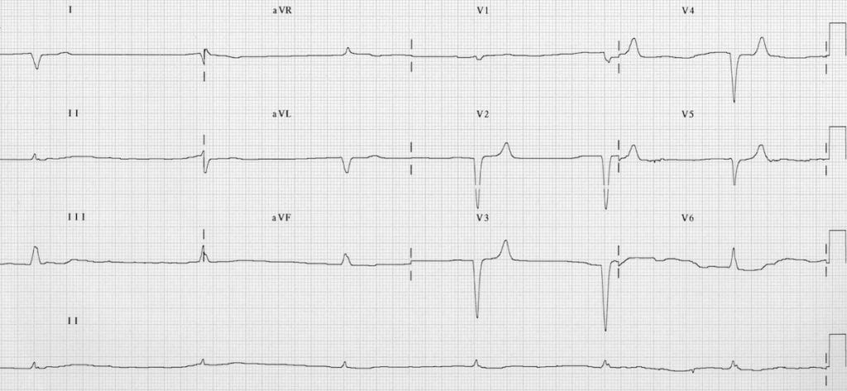
Sinusoid
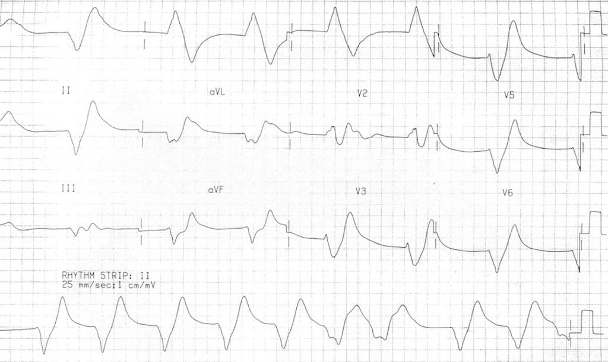
https://litfl.com/hyperkalaemia-ecg-library/

Appendix C: Facilitator Cheat Sheet & Debriefing Tips

Include key errors to watch for and common challenges with the case. List issues expected to be part of the debriefing discussion. Supplemental information regarding any relevant pathophysiology, guidelines, or management information that may be reviewed during debriefing should be provided for facilitators to have as a reference.

- Review the initial approach to bradycardia (ie DIE mnemonic: drugs, ischemia, electrolytes… or any other mnemonic you like!)
- Discuss the approach to the patient with symptomatic bradycardia
- Review the medical treatment for severe hyperkalemia
- Review the options for help during the night (senior resident, RACE team, on-call staff)

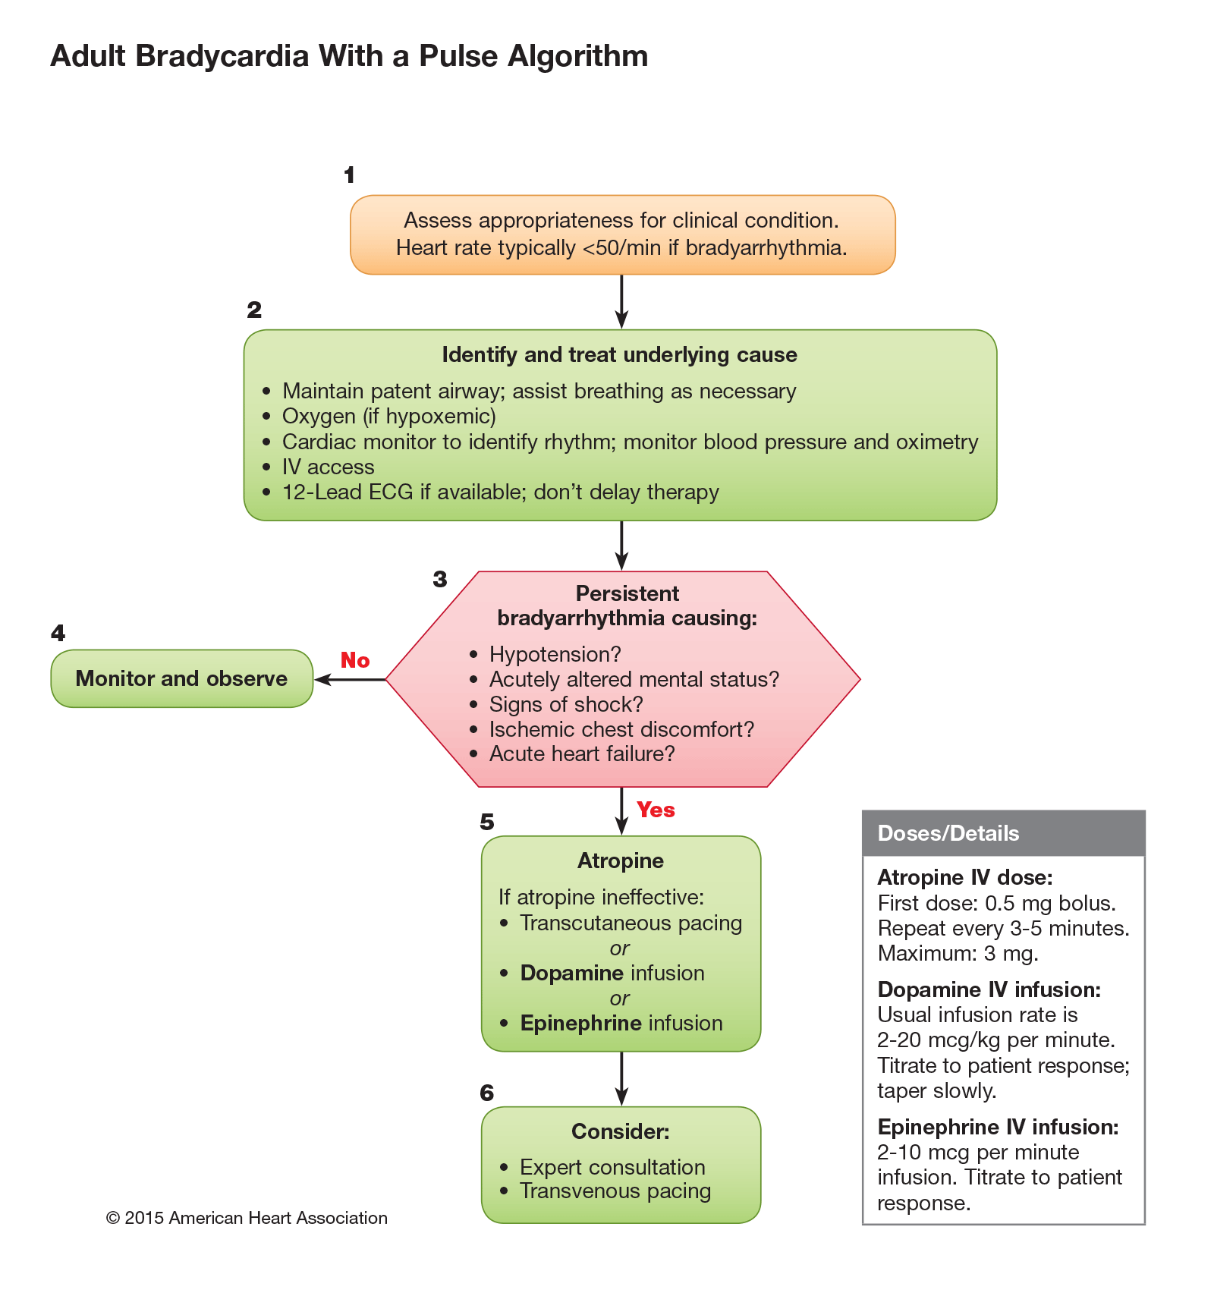

References

1. ACLS Bradycardia with a Pulse algorithm
2. https://emergencymedicinecases.com/emergency-management-hyperkalemia/
3.

